

Microsoft Partner

Gold Cloud Platform

Gold Devices and Deployment

Gold Application Lifecycle Management

Gold Application Development

Gold Cloud Productivity

Physical Machine Deployment using SCCM

**Prepared By: NathCorp**

**Team detail**

Abhishek Kumar

Neeraj Kumar

**In the guidance of:**

Mayank Pahan

**Description:**

OS and application deployment in physical machine via PXE boot using SCCM.

## Client Specification

**Processor** **->** Intel Core 2 duo

**RAM** **->** 2GB

**System type** **->** 64-bit OS

**OS installed** **->** Win 10 1703 (OS build 15063.0)

**MAC** **->** 00: 22: 68: 0C: 13: 0F

## Requirement

### Hardware Requirements

* A physical machine
* 2 LAN cables
* A hub/switch

### Software Requirements

* AD server
* Configured SCCM server
* OS image

## Environment setup for PXE

### Add laptop to same network

Created external virtual switch in Hyper-V.

### Enabling PXE Boot for Lenovo ThinkPad

1. Boot up computer.
2. Press F2 **->** press F1.
3. This should take you to the BIOS screen. Select boot menu.
4. Select PCI LAN and set to top of the boot priority.
5. Press F10 for save and exit.

## Method 1: SCCM

### Adding Boot image

Add boot image (boot.wim) and distribute it.

Go to Software Library -**>** Operating Systems -**>** Boot Images Steps to add boot image:

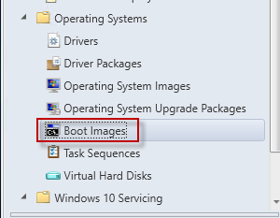

Right Click on Boot Images (x64) and Click Properties

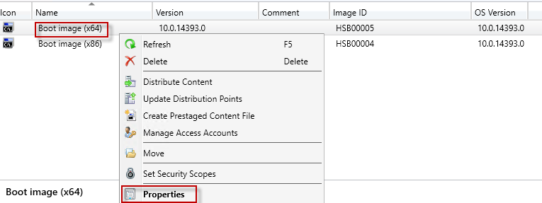

Go to **Data Source** tab

Make sure that Deploy this boot image from the PXE-enabled distribution point is checked

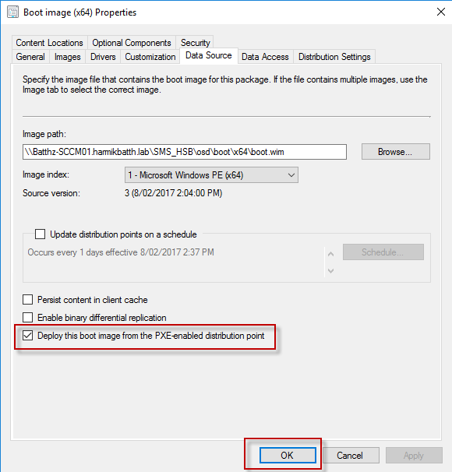

Go to **Customization** tab

Check Enable command support (testing only)

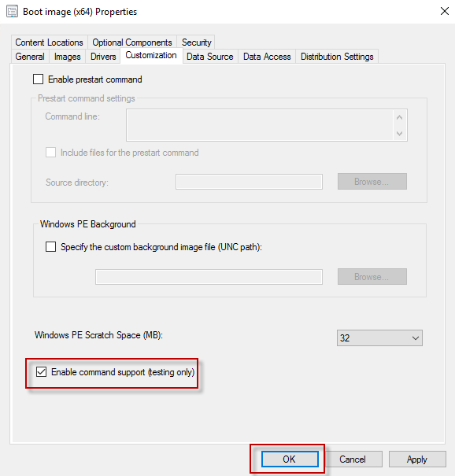

Enable command support (testing only), will allow to troubleshoot OS deployment issues.

This complete the Boot Images configuration!

### Adding OS image

Add OS image (install.wim) and distribute it.

**Steps to add Operating System image:**

To add an Operating System Image in SCCM 2016, just Launch SCCM Console and Go to Software Library > Operating systems.

Right Click on Operating Systems, click on “Add OS image”

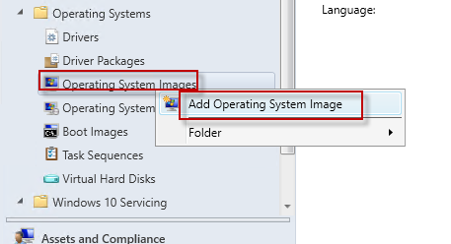

Specify the path to the Operating system image file. It must be UNC path.

Click **Next** to Continue

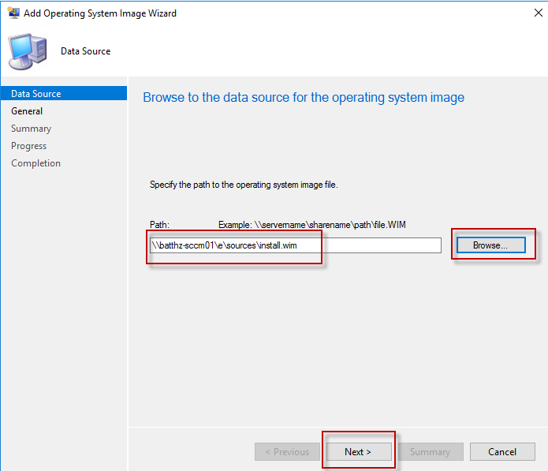

Specify Name, Version and or any comments.

Click **Next** to Continue

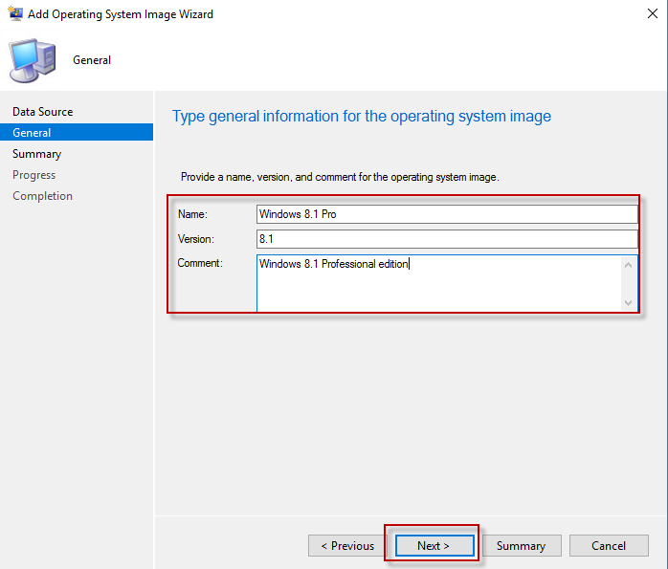

To Create the Operating System Image, Click **Next**

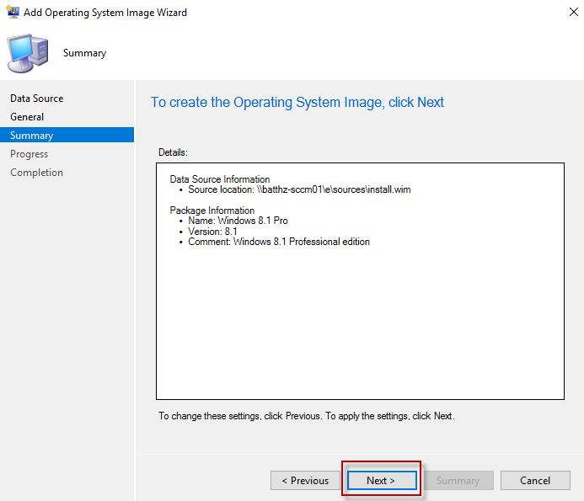

Wizard will provide you details of the task whether it is completed successfully or not.

Click **Close** to Finish.

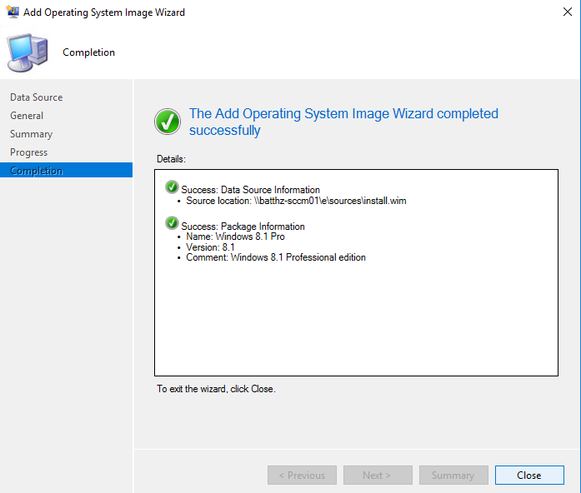

### Creating task sequence

**Steps:**

1.Go to software library -> OS ->Task Sequence.

2.Select “install an existing image package”.

3.Give task sequence name.

4.Select boot image (boot.wim) [x64 or x86] that can be found under sources folder in windows setup folder.

5.Select OS image package.

6.Select “enable the account and specify the local admin password” and give any password

7.Select workgroup or join a domain

If you select “join a domain”, then you need to give domain user credential for domain connection and verify it.

8.Do not capture any settings and files, not even network setting or windows settings.

9.Do not install any software or you can according to your wish.

10.complete creating task sequence.

**NOTE:**

Go to boot image properties of **x64** and **x86** individually, check whether “Deploy this boot image from the PXE-enabled DP” in data source tab. If not, enable it.

### DHCP Configuration

**NOTE:** We need to append option 66 and 67 because we are having AD and WDS in different server.

To Configure, Connect to DHCP Server.

Go to Required Scope

Right Click on Scope Options and Click Configure Options.

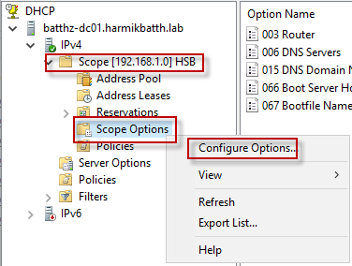

Look for Option **66** & **67**.

Options 66, Specify Name(FQDN) or IP Address of Distribution point with PXE-enabled support.

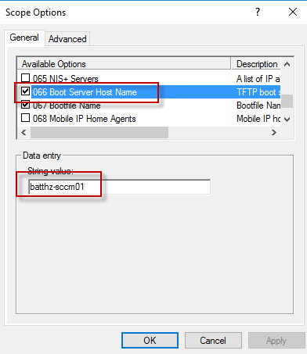

Options 67, specify Boot\x64\wdsnbp.com

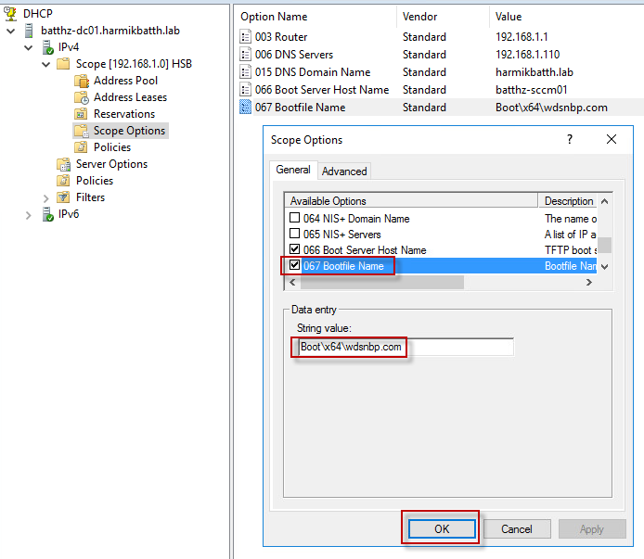

**Check for PXE support is enabled in DP:**

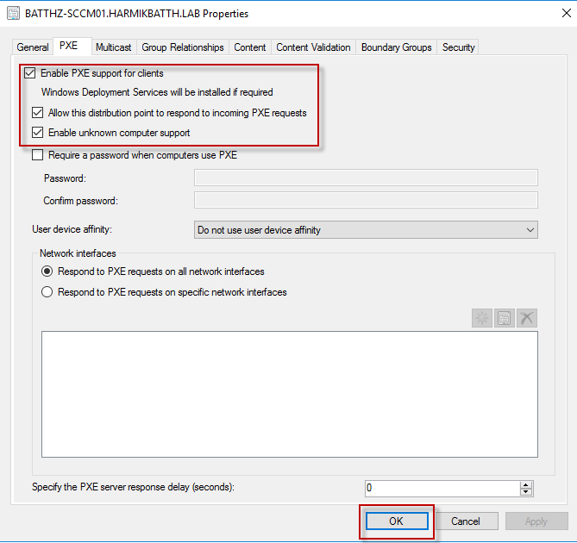

Now, Deploy the task sequence.

Make sure you have selected

* “configuration manager clients, media and PXE” in deployment settings
* “when no local DP is available, use remote DP”

Now, restart the client machine which is configured for network boot.

### Monitor logs

Check log file to monitor task sequence process

* Press f8 for opening CMD, write “notepad”
* Select “all file type” and browse SMSTS.log.

### PXE OSD reports

It can be seen in SCCM console itself.

In console, go to Reporting **->** reports **->** reports **->** task sequence **->** deployments.

### Troubleshooting steps

#### Problems faced during implementing the task

##### Problems before PXE boot

1. Connection issue
2. PXE boot failed in Gen1 machine while started in Gen2 machine
3. No boot filename received
4. PXE-E32: TFTP open timeout
5. No response from Windows Deployment Services Server
6. PXE-E55: ProxyDHCP service did not reply to request on 4011
7. Access Violation
8. Boot Failure Recovery issue
9. Bootable media not created

* **Steps taken for Resolving “**Connection Issue**” –**

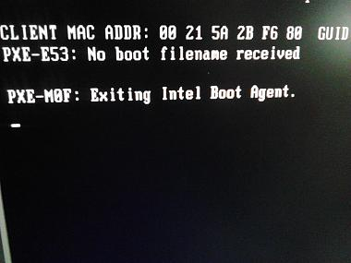

* Created External Switch
* Assigned Static IP to it in the AD & SCCM Server
* Pinging each machine to establish connection between systems
* **Steps taken for Resolving “**PXE-E32: TFTP open timeout**”** **–**

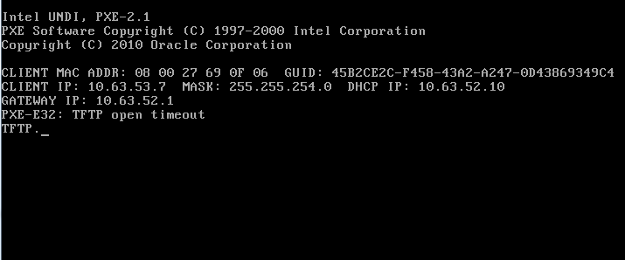

* Go to DHCP server
* Right click on scope options
* Select options 066 (Boot Server Host Name) & provide value. (value = FQDN of SCCM server)
* Select options 067 (Boot File Name) & provide value. (value = “smsboot\x64\wdsnbp.com”)
* Click OK
* **Steps taken for Resolving “**NO response from Windows Deployment Services Server**”** **issue –**

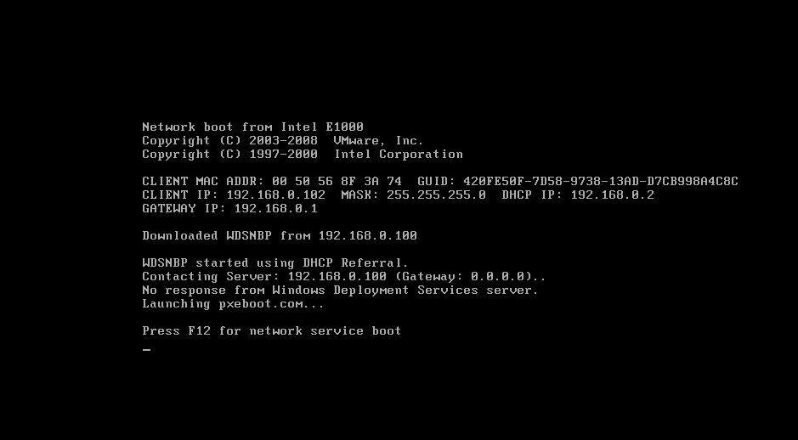

* Go to Windows Deployment Services server
* Right Click on Boot images
* Add boot.wim
* Also, go to the properties of Server
* Go to the PXE tab
* Check “Respond to all unknown computers”
* Click OK
* **Steps taken for Resolving “**PXE-E55: ProxyDHCP service did not reply to request on 4011**”** **issue –**

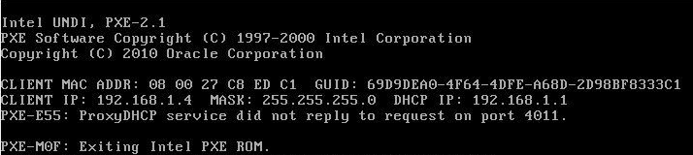

* Go to DHCP server
* Right click on Server options
* Select options 060 & provide value. (value = PXEClient)
* Click OK
* **Steps taken for Resolving PXE boot failure issue –**

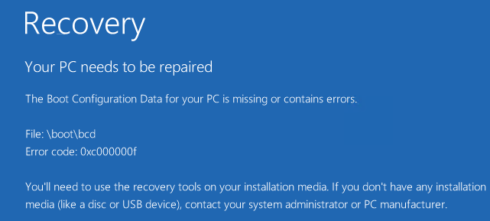

**Step 1 –**

* In Scope option 067 (Boot File Name), changed the boot file name.
* Provided following values -
* value = “smsboot\x64\wdsnbp.com”
* value = “smsboot\x86\wdsnbp.com”
* value = “smsboot\x64\wdsnbp”
* value = “smsboot\x86\wdsnbp”
* value = “smsboot\boot.sdi”
* value = “smsboot\x64\pxeboot.n12”
* value = “smsboot\x64\bootmgr.com”
* value = “smsboot\x64\bootmgrw.efi”
* value = “smsboot\x64\abortpxe.com”
* value = “smsboot\x64\wdsnbpw.efi”
* Click OK

**Step 2 –**

* In Distribution point properties unchecked the PXE and multicast and rechecked it

**Step 3 –**

* Stopped WDS Server
* Restarted WDS Server

**Step 4 –**

* Go to properties of WDS Server
* In PXE Boot tab check the option “Respond to all unknown computers”

**Step 5 –**

* Tried to create bootable media
* Pen drive is not showing as removable device
* Tried to troubleshoot it
* Bootable media not created

**Step 6 –**

* Created the bootable media for Recovery
* Restarted system
* Insert bootable media
* Select Troubleshoot
* Select Command Prompt
* Type “bootrec/FixMbr” and press ENTER.
* Now, Type “bootrec/FixBoot” and press ENTER.
* After that, Type “bootrec/ScanOs” and press ENTER.
* Type “bootrec/RebuildBcd” and press ENTER.

**Step 7 –**

* Updated distribution point
* Deployed Task Sequence

**Step 8 –**

* Check if all components like Bootimages, OS-Images, Task-Sequences and Announcements are published to all distribution-points
* Check if there is a processing-failure during the distribution
* Check permissions on file-System (insert "system"-account and SCCM PXE-Point FQDN with Full-Acces (share and security permissions))
* Add the network-access acount with Domain-Administration Status
* Update the Network Driver to the Bootimages
* Add the client computer to SCCM "Computers"-Section (Import with MAC-Address) and create Task-Sequence Announcement to this Selection
* Try to clear Client-PCs PXE-Announcements
* Check if there are both boot Images deployed (x64 and x86) and distributed to DPs

**Step 9 –**

* Remove Distribution point role
* Again, added DP
* Distributed Contents
* Created Task Sequence
* Deployed it

**Step 10 –**

* Monitored Log file SMSPXE.log
* Analyzed it
* For this log file, follow the path - C:\Program Files\Microsoft Configuration Manager\Logs\SMSPXE.log

##### Problems after PXE boot

* + - 1. OS installation error
      2. PXE-E51: No DHCP or Proxy DHCP offers were received
      3. PXE-E55: ProxyDHCP service did not reply to request on 4011
* **Steps taken for Resolving “**OS installation error**” -**

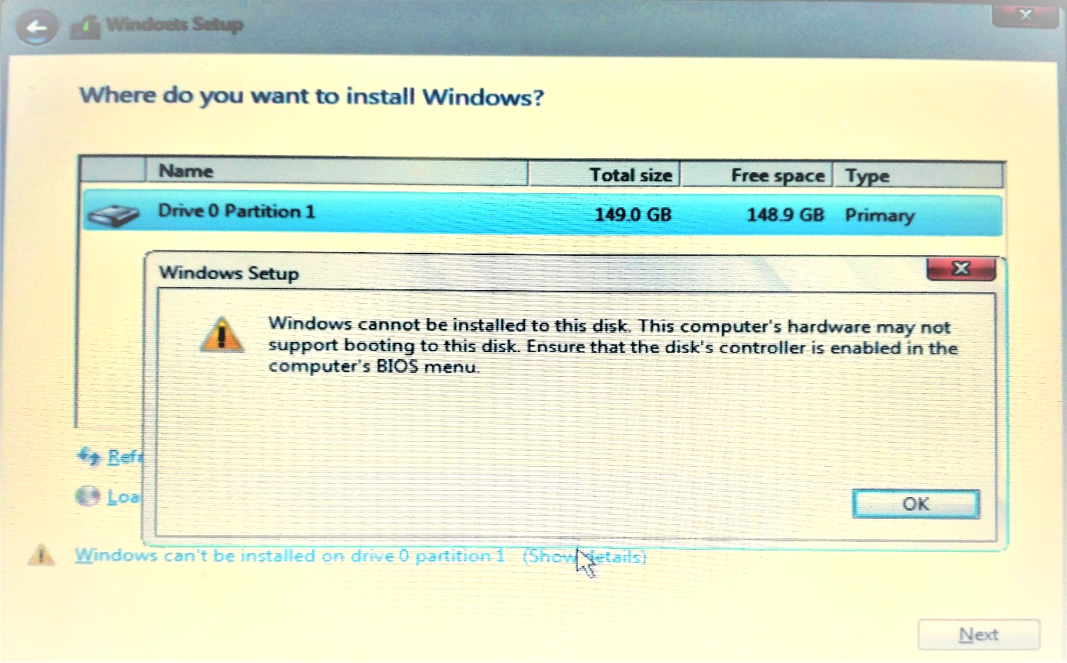

* Go to the BIOS setup of the system
* Go to the Boot priority order
* Added HDD to the Boot priority list
* Restarted PXE boot
* 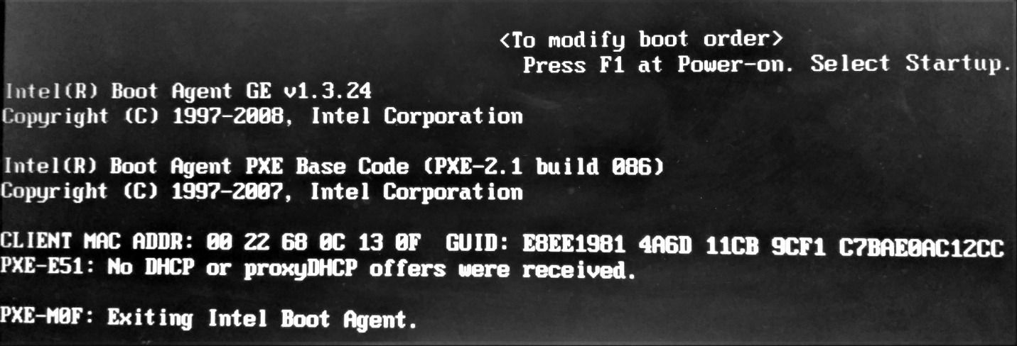**Steps taken for Resolving “**PXE-E51: No DHCP or ProxyDHCP offers were received**” –**
* Check whether the connection to the network is properly established or not
* Pinging each machine to check connection between systems
* **Steps taken for Resolving “**PXE-E55: ProxyDHCP service did not reply to request on 4011**” -**



* Restarted WDS Server

#### Summary table for troubleshooting

|  |  |  |
| --- | --- | --- |
| S. No. | Problem | Resolution Steps   * Worked * Not worked |
| 1 | Connection issue | * Created External Switch * Assigned Static IP to it in the AD & SCCM Server * Pinging each machine to establish connection between systems |
| 2 | PXE-E32: TFTP open timeout | * Go to DHCP server * Right click on scope options * Select options 066 (Boot Server Host Name) & provide value. (value = FQDN of SCCM server) * Select options 067 (Boot File Name) & provide value. (value = “smsboot\x64\wdsnbp.com”) * Click OK |
| 3 | PXE-E55: ProxyDHCP service did not reply to request on 4011 | * Go to DHCP server * Right click on Server options * Select options 060 & provide value. (value = PXEClient) * Click OK |
| 4 | No response from Windows Deployment Services Server | * Go to Windows Deployment Services server * Right Click on Boot images * Add boot.wim * Also, go to the properties of Server * Go to the PXE tab * Check “Respond to all unknown computers” * Click OK |
| 5 | Boot Failure Recovery issue | * Created the bootable media for Recovery * Restarted system * Insert bootable media * Select Troubleshoot * Select Command Prompt * Type “bootrec/FixMbr” and press ENTER. * Now, Type “bootrec/FixBoot” and press ENTER. * After that, Type “bootrec/ScanOs” and press ENTER. * Type “bootrec/RebuildBcd” and press ENTER. |
| 6 | Bit locker Recovery Error in physical system | * Created bootable media (USB) * Formatted System * Installed OS * Restarted system |
| 7 | Contents are missing at RemoteInstall\SMSImages | * Check whether boot images are configured fox PXE * Update Distribution Point |
| 8 | OS installation error | * Go to the BIOS setup of the system * Go to the Boot priority order * Added HDD to the list * Restarted PXE boot |
| 9 | PXE-E51: No DHCP or ProxyDHCP offers were received | * Check whether the connection to the network is properly established or not * Pinging each machine to check connection between systems |
| 10 | PXE-E55: ProxyDHCP service did not reply to request on 4011 | * Restarted WDS Server |

## Method 2: WDS

1. Create a VM and install win Server OS for AD and WDS.
2. Connect this VM with external switch.
3. Install ADDS, DHCP, DNS and WDS from server manager.
4. Create static IP for this system.
5. Configure ADDS for promoting your system to domain.
6. Configure DHCP, DNS respectively.
7. Configure WDS.
   1. Add boot image (boot.wim) of windows 10 (which is under \sources folder).
   2. Add OS image (install.wim) of windows 10.

Now, restart the client machine which is configured for network boot.

## Method 3: Using Boot media

**1.Adding boot media**

1. Go to task sequence **->** create task sequence media.
2. Select “bootable media” and click **next.**
3. Select “site-based media” and click **next.**
4. Give “ISO name” and save, click **next.**
5. Select “boot image”.
6. Select your **DP.**
7. Select your **MP.**
8. Click **next** and **close**.

2. Now, create bootable of this ISO file (using power ISO).

3. Start client machine with bootable USB.

4. Deploy the task sequence of OSD to device collection.

5. Select task sequence.